Project Design Phase
Solution Architecture

Date | 30 June 2026
Team ID
Project Name | Smart Agricultural Production Optimization Engine
Maximum Marks | 4 Marks

Solution Architecture:
Solution architecture is a complex process – with many sub-processes – that bridges the gap between business problems and technology solutions. Its goals are to:
- Find the best tech solution to solve existing business problems.
- Describe the structure, characteristics, behavior, and other aspects of the software to project stakeholders.
- Define features, development phases, and solution requirements.
- Provide specifications according to which the solution is defined, managed, and delivered.

Solution Architecture Diagram:
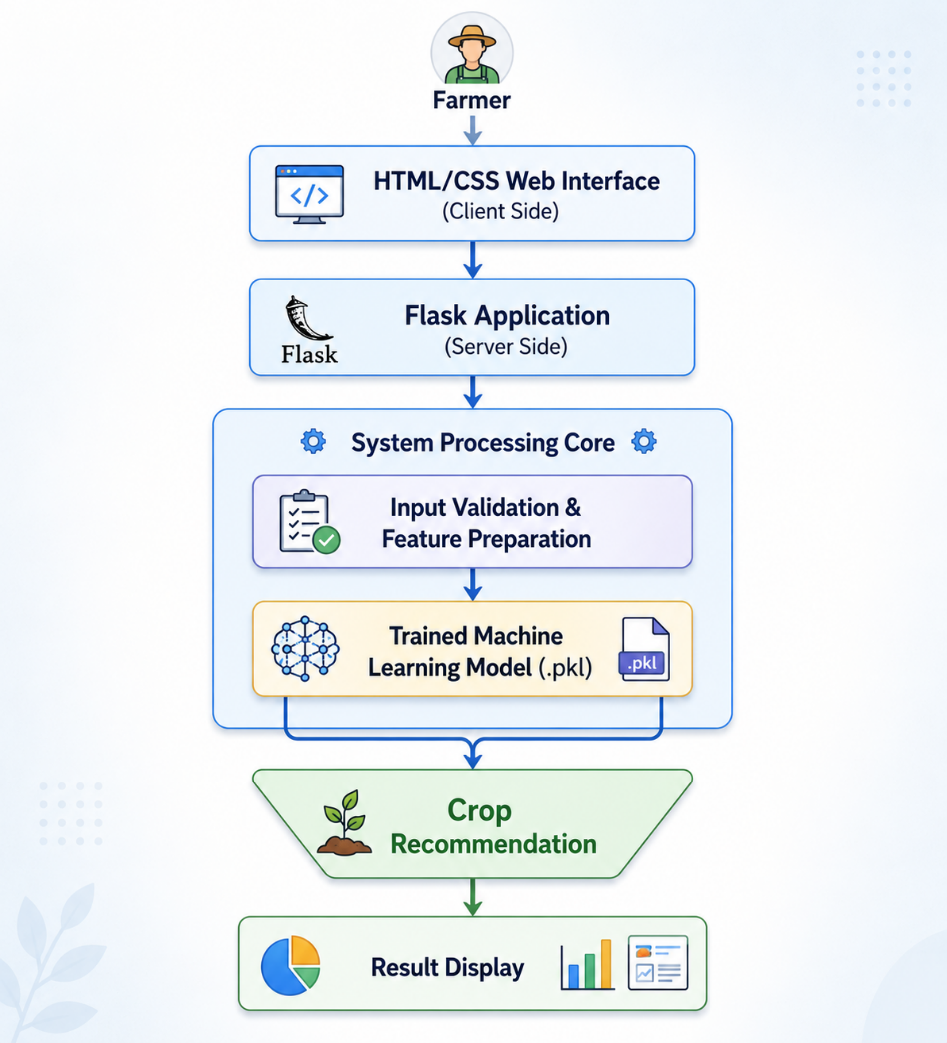

Solution Architecture Description
The Smart Agricultural Production Optimization Engine (OptiCrop) follows a Flask-based machine learning architecture for crop recommendation. Farmers interact with the system through a user-friendly HTML/CSS web interface where they enter soil nutrient values (Nitrogen, Phosphorus, Potassium, and pH) along with environmental parameters such as temperature, humidity, and rainfall. The Flask application receives the user inputs, performs input validation and feature preparation, and loads the trained machine learning model stored as a .pkl file using Joblib. The machine learning model, developed using Scikit-learn with support from Pandas and NumPy during model development, predicts the most suitable crop based on the provided inputs. The predicted crop recommendation is then displayed through the web interface, enabling farmers to make informed and data-driven crop selection decisions for improved agricultural productivity and sustainable farming.

